UNITED STATES
SECURITIES AND EXCHANGE COMMISSION
Washington, DC 20549

FORM 8-K

CURRENT REPORT

Pursuant to Section 13 or 15(d) of the Securities Exchange Act of 1934

Date of report (Date of earliest event reported): June 15, 2026

Motorsport Games Inc.
(Exact name of registrant as specified in its charter)

Delaware |  | 001-39868 |  | 86-1791356
(State or other jurisdiction  of incorporation) |  | (Commission  File Number) |  | (I.R.S. Employer  Identification No.)

3350 SW 148th Avenue, Suite 207  Miramar FL |  | 33027
(Address of principal executive offices) |  | (Zip Code)

Registrant’s telephone number, including area code: (305) 413-0812

N/A
(Former name or former address, if changed since last report)

Check the appropriate box below if the Form 8-K filing is intended to simultaneously satisfy the filing obligation of the registrant under any of the following provisions:

☐ | Written communications pursuant to Rule 425 under the Securities Act (17 CFR 230.425)
☐ | Soliciting material pursuant to Rule 14a-12 under the Exchange Act (17 CFR 240.14a-12)
☐ | Pre-commencement communications pursuant to Rule 14d-2(b) under the Exchange Act (17 CFR 240.14d-2(b))
☐ | Pre-commencement communications pursuant to Rule 13e-4(c) under the Exchange Act (17 CFR 240.13e-4(c))

Securities registered pursuant to Section 12(b) of the Act:

Title of each class |  | Trading Symbol(s) |  | Name of each exchange on which registered
Class A common stock, $0.0001 par value per share |  | MSGM |  | The Nasdaq Stock Market LLC  (The Nasdaq Capital Market)

Indicate by check mark whether the registrant is an emerging growth company as defined in Rule 405 of the Securities Act of 1933 (§230.405 of this chapter) or Rule 12b-2 of the Securities Exchange Act of 1934 (§240.12b-2 of this chapter).

Emerging growth company ☒

If an emerging growth company, indicate by check mark if the registrant has elected not to use the extended transition period for complying with any new or revised financial accounting standards provided pursuant to Section 13(a) of the Exchange Act. ☐

Item 1.01 Entry into a Material Definitive Agreement.

On June 15, 2026, Motorsport Games Inc. (the “Company”) entered into an Amendment to Business Loan Agreement (the “Credit Agreement Amendment”) with Citibank, N.A. (“Citibank”), amending the Business Loan Agreement, dated February 20, 2026 (the “Credit Agreement”), between the Company and Citibank, pursuant to which Citibank has provided the Company with a revolving line of credit. The Amendment modifies an affirmative covenant relating to the Company’s level of fixed charges by revising the definition of Fixed Charge Coverage Ratio. Under the Amendment, the Company’s cash interest expenses will be added to the denominator of the Fixed Charge Coverage Ratio. The parties also entered into an amendment (the “Promissory Note Amendment”) to the promissory note relating to the Credit Agreement (the “Promissory Note”) extending the maturity date of the Promissory Note from February 20, 2027, to February 20, 2028.

The foregoing descriptions of the Amendment, the Credit Agreement, the Promissory Note Amendment, and the Promissory Note are qualified in their entirety by reference to the full text of such agreements, forms or copies of which are attached hereto as Exhibits 10.2, 10.1, 10.3, and 10.4, respectively, and each of which is incorporated herein in its entirety by reference. The representations, warranties and covenants contained in such agreements were made only for purposes of such agreements and as of specific dates, were solely for the benefit of the parties to such agreements and may be subject to limitations agreed upon by the contracting parties.

Item 2.03 Creation of a Direct Financial Obligation or an Obligation under an Off-Balance Sheet Arrangement of a Registrant.

The information set forth above under Item 1.01 is hereby incorporated by reference into this Item 2.03.

Item 9.01 Financial Statements and Exhibits.

(d) Exhibits

 | 10.1 | Business Loan Agreement, dated February 20, 2026, by and between Motorsport Games Inc. and Citibank, N.A. (incorporated by reference to Exhibit 10.1 to the Company’s Current Report on Form 8-K, File No. 001-39868, filed with the Securities and Exchange Commission on February 25, 2026)
 | 10.2 | Amendment to Business Loan Agreement, dated June 15, 2026, by and between Motorsport Games Inc. and Citibank, N.A.
 | 10.3 | Promissory Note, dated February 20, 2026, in favor of Citibank, N.A. (incorporated by reference to Exhibit 10.2 to the Company’s Current Report on Form 8-K, File No. 001-39868, filed with the Securities and Exchange Commission on February 25, 2026)
 | 10.4 | Amendment to Promissory Note, dated June 15, 2026, in favor of Citibank, N.A.
 | 104 | Cover Page Interactive Data File (embedded within the Inline XBRL document)

SIGNATURES

Pursuant to the requirements of the Securities Exchange Act of 1934, the registrant has duly caused this report to be signed on its behalf by the undersigned hereunto duly authorized.

 | Motorsport Games Inc.
Date: June 18, 2026 | By: | /s/ Stephen Hood
 |  | Stephen Hood
 |  | Chief Executive Officer and President

Exhibit 10.2
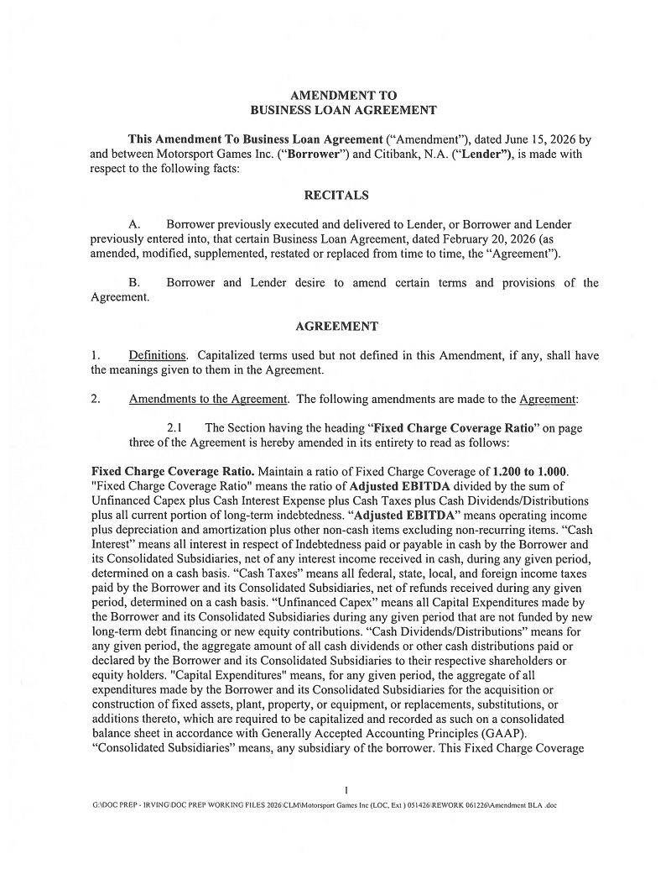

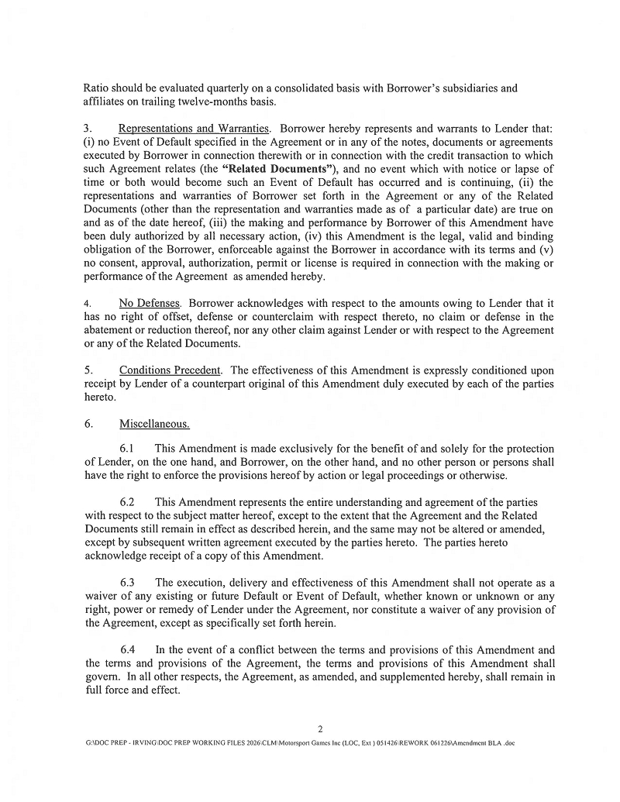

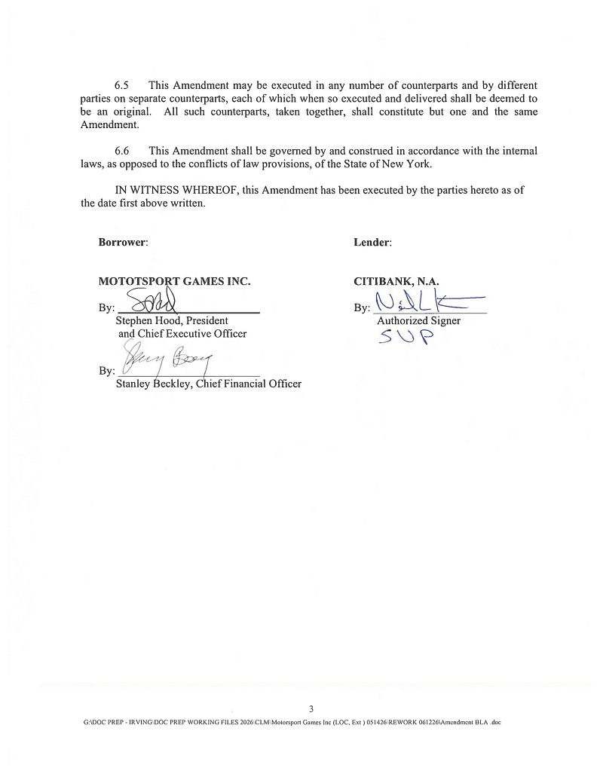

Exhibit 10.4


